# Quiz # 3 Web Programming - Section (B)

**Total Marks: 10 Time: 40 minutes**

1. What is dependency injection. Explain the steps to remove it from MVC project with the help of an example (5 marks)

**Make interface in models of student class, download and install ninject web common then bind interface with class**

1. Make the following view using html helpers (5 marks)

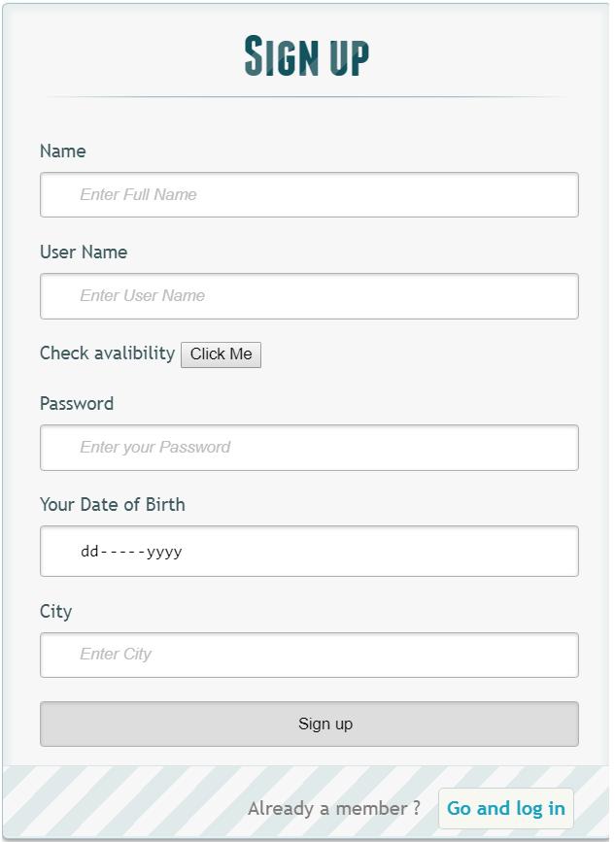

**@using (Html.BeginForm("signUp","Home",FormMethod.Post)){**

**<h1> Sign up </h1>**

**<p>**

**@Html.Label("","Name")**

**@Html.TextBoxFor(m => m.fname, new {placeholder="Enter Full Name" , required="required"})**

**@Html.ValidationMessageFor(m =>m.fname)**

**</p>**

**<p>**

**@Html.Label("","User Name")**

**@Html.TextBoxFor(m => m.uname, new {placeholder="Enter User Name" , required="required"})**

**@Html.ValidationMessageFor(m =>m.uname)**

**</p>**

**<p>**

**@Html.Label("","Check avalibility")**

**<button id="username_check" name="username_check" onclick="f1()"> Click Me </button>**

**</p>**

**<p>**

**@Html.Label("","Password")**

**@Html.TextBoxFor(m => m.pwd, new {placeholder="Enter your Password" , required="required" })**

**@Html.ValidationMessageFor(m =>m.pwd)**

**</p>**

**<p>**

**@Html.Label("","Your Date of Birth")**

**<input id="userdob" name="dob" required="required" type="date" />**

**</p>**

**<p>**

**@Html.Label("", "City")**

**@Html.TextBoxFor(m => m.city, new {placeholder="Enter City" , required="required"})**

**@Html.ValidationMessageFor(m =>m.city)**

**</p>**

**<p >**

**<input type="submit" value="Sign up"/>**

**</p>**

**<p class="change_link">**

**Already a member ? <a href="#tologin" class="to_register"> Go and log in </a>**

**</p>**

**}**